**Thursday February 1st.**

Global review : what we worked on yesterday + language basics.

LINGUAHOUSE Reviews 1 2 3 4

Simple present / word order with frequency adverbs review:

**Julie:** So, what do you do in your free time?

**Richard:** Well, I **often** watch TV in the evening. What about you?

**Julie:** I go jogging, and I **sometimes** meet friends in the evening.

**Richard:** How often do you go jogging?

**Julie:** I go jogging every morning. And you?

**Richard:** I **hardly ever** go jogging. Maybe once a year!

**Julie:** Do you cook?

**Richard:** No, I **never** cook. I **always** order pizza. And you?

**Julie:** I cook every day. I love cooking!

**Richard:** How often do you travel?

**Julie:** I travel twice a year. In winter, I **usually** go skiing. Do you travel?

**Richard:** Yes, I do. Every summer. But I **rarely** travel in winter.

Common verbs review:

MAKE phone calls

WRITE emails in English

MANAGE clients (gérer/s’occuper de)

Syn. of participate : ATTEND meetings

I NEED an update on your progress.

DEAL with suppliers

GIVE presentations

INTERVIEW job candidates

We are ABLE TO develop app and softwares.

Phone vocab review : 04.25 : <https://www.youtube.com/watch?v=01zt_awXjlU>

Technical vocabulary for IT professionals: top words and phrases to learn

As promised at the beginning… here’s a list of the most frequently used words and phrases related to the IT industry that would be essential for any tech professional to learn:

0. Bug: A mistake in a computer program that makes it act wrong or not work properly.

1. Code: Instructions, written in a programming language, that tell a computer what actions to perform.
2. Data Center: A facility housing computer servers and networking equipment for storing, processing, and managing data.
3. Encryption: Changing data into a secret code so others can’t easily read it without permission.
4. Full Stack: Refers to a developer skilled in both front-end and back-end development, capable of working on all layers of a software application.
5. Hacker: A person who uses technical skills to exploit vulnerabilities in computer systems or networks, either for malicious purposes or ethical hacking to improve security.
6. Patch: A software update designed to fix bugs or vulnerabilities or improve functionality in an existing program.
7. SQL (Structured Query Language): A language used for managing and querying relational databases.
8. UI/UX (User Interface/User Experience): UI is how the software looks, and UX is how it feels to use.
9. XML (eXtensible Markup Language): A markup language used for storing and transmitting structured data.
10. Agile: A way to make software where teams work together in small steps and can easily make changes as needed.
11. Backup and Recovery: Processes and strategies for creating copies of data and systems to restore them in case of data loss or system failures.
12. Zero-Day Exploit: A cyberattack that takes advantage of a vulnerability in software before the vendor releases a patch or fix for it.
    * Note : all student have chosen a word in this list or a word related to their field and had the class guess the word by defining it, miming, drawing etc.
    * Student have translated some useful sentences from French to English.

For example: Just before the release, we’ve been faced with a data breach.

We have used this website for a short review of global computer related vocabulary (basic) + keyboard shortcuts.<https://www.proprofs.com/quiz-school/topic/computer-vocabulary>

Enough 😊 Let’s work on comprehension now:

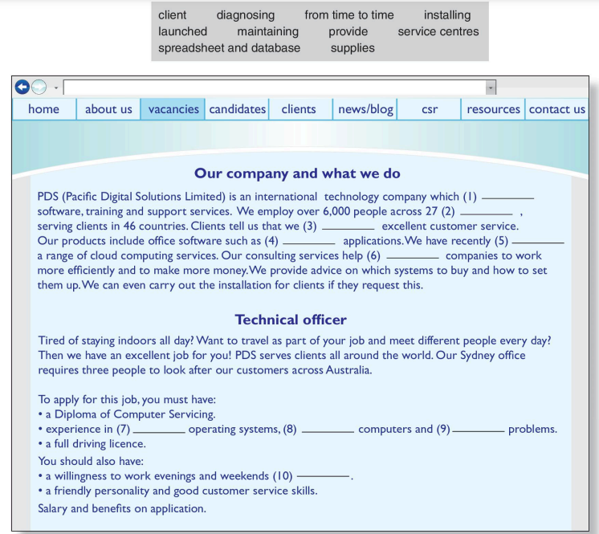

## Bonus: general words and phrases commonly used in an IT business environment:

1. Communication Skills: The ability to convey information clearly and effectively through various means, such as written, verbal, and nonverbal communication.
2. Problem-Solving: The process of analyzing and resolving challenges or issues systematically and logically.
3. Decision Making: The process of choosing a course of action from various alternatives based on careful consideration of available information.
4. Time Management: Effectively planning and allocating time to tasks and activities to maximize productivity and meet deadlines.
5. Project Management: Planning, executing, and controlling projects to achieve specific goals and deliverables within constraints like time, budget, and resources.
6. Leadership: Guiding, motivating, and influencing a team to achieve objectives and produce results.
7. Teamwork: Collaborating and cooperating with others within a group to achieve a shared goal.
8. Presentation Skills: Effectively conveying information to an audience through engaging and organized presentations.
9. Customer Service: Providing assistance, support, and solutions to meet customer needs and ensure satisfaction.
10. Risk Management: Identifying, assessing, and mitigating potential risks that could impact a project, process, or organization.
11. Change Management: Guiding individuals and teams through transitions, particularly when implementing new processes, technologies, or strategies.
12. ROI (Return on Investment): How much profit or loss you get from money you’ve spent or invested.
13. Workflow: The sequence of tasks, activities, and processes that are completed to achieve a particular goal or outcome.
14. Compliance: Adhering to laws, regulations, standards, and policies applicable to a specific industry or organization.
15. Disaster Recovery: Implementing strategies and procedures to recover IT systems and data following a major disruption or failure.
16. Business Analysis: Identifying and defining business needs and solutions to drive improvements and meet objectives.
17. Digital Transformation: Integrating digital technologies and strategies into all aspects of a business to drive innovation, efficiency, and customer value.
18. Data Privacy: Measures and regulations to protect the confidentiality and control of personal and sensitive data.
19. Incident Management: Responding to and resolving unexpected disruptions or incidents to restore normal operations.
20. Change Management: Guiding individuals and teams through transitions, particularly when implementing new processes, technologies, or strategies.
21. Asset Management: Monitoring and optimizing the lifecycle of physical and digital assets, such as hardware, software, and licenses.
22. User Access Control: Implementing policies and technologies to manage and restrict user access to sensitive resources.
23. Business Process: A bunch of steps or jobs done together to reach a business goal.
24. E-business: Conducting business activities electronically, encompassing aspects like e-commerce, online marketing, and customer service.
25. CRM (Customer Relationship Management): Strategies, technologies, and practices used to manage interactions and relationships with customers.
26. ERP (Enterprise Resource Planning): Integrated software systems that manage different business functions, such as finance, human resources, and supply chain.
27. BI (Business Intelligence): Technologies and processes that analyze and present business data to support decision-making.
28. Reporting: Presenting information and data in a structured format to convey insights and support decision-making.
29. Productivity: The efficiency and output of work or processes, often measured against resources used.
30. Efficiency: Achieving maximum output with minimum resources or effort, optimizing processes, and reducing waste.
31. Workflow: The sequence of tasks, activities, and processes that are completed to achieve a particular goal or outcome.
32. Market Research: Collecting and analyzing data about markets, customers, and trends to inform business decisions.
33. Customer Insights: Information gained from analyzing customer behavior, preferences, and feedback to improve products and services.
34. Branding: Establishing and promoting a distinct and recognizable image, identity, and reputation for a product or organization.
35. Sales Funnel: The step-by-step process that potential customers go through when considering and making a purchase.
36. Target Audience: The specific group of people that a product, service, or marketing campaign is intended to reach and engage.
37. Customer Engagement: The interaction and connection between a brand and its customers, often measured by interactions and loyalty.
38. Customer Retention: Ways to keep and build a good relationship with current customers.

Let’s talk about those skills!

Technical documentation…

Reading and understanding the gist of it!

Work on general English skills :

<https://www.pearson.pl/fileadmin/poland/english/products/files/sample_files/English-for-IT-2-sb-sample-unit.pdf>

Page 6 and 7

Games:

<https://eslactive.com/best-esl-games-for-adults/>

Do you know

<https://www.codingame.com/start/fr/>